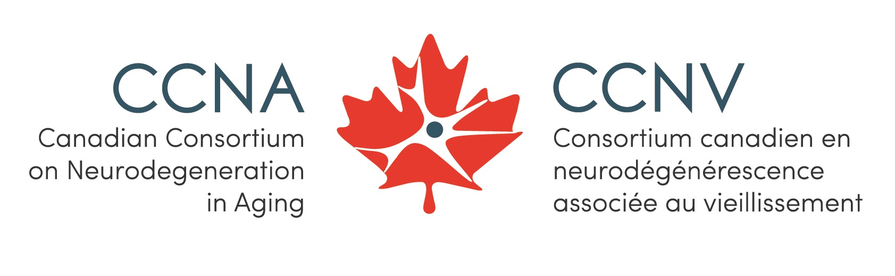
CCNA Virtual Partners Forum and Science Days 2020
WORKING TOGETHER TO END DEMENTIA
FINAL PROGRAM

PRE-CONFERENCE ELSI EVENT: October 13
PARTNERS FORUM AND SCIENCE DAYS: October 14 – 16
POST-EVENT WORKSHOPS AND SPECIAL SESSIONS: October 19 – 30

Some sessions are pre-recorded, others are live only. The recorded sessions will be available for on-demand viewing prior to their scheduled time. They will also be presented during their scheduled times and followed by live Q&A sessions. All scheduled times are in Eastern Daylight Time (EDT).

TUESDAY, OCTOBER 13, 2020 – Pre-conference event: Ethical, Legal, and Social Implications
11:30 am – 12:30 pm | Learning from and working with participants in ELSI: The experience of the European Prevention of Alzheimer’s Dementia project  Guest Speaker: Richard Milne  Presenters: Julie Robillard, John Fisk  Available on-demand and at this time, followed by a live Q&A
REVISED  5:30 – 6:30 pm | ELSI Trainee workshop: What can ELSI do for me? Exploring the ethical, legal, and social implications of CCNA dementia research  Leaders: Julie Robillard, John Fisk  Live presentation

WEDNESDAY, OCTOBER 14, 2020 – CCNA Annual Event
10:30 am – 11:15 am | Messages and opening statement  Howard Chertkow, Scientific Director, CCNA  Elder Jean McGregor-Andrews, Michael Strong, President of CIHR  Available on-demand and at this time
11:30 am – 1:00 pm | Panel: Research on dementia and COVID-19  Moderator: Zahinoor Ismail  Panelists: Katherine McGilton, Eric Smith, Isabelle Vedel  Available on-demand and at this time, followed by a live Q&A
1:30 pm – 4:00 pm | iTRIC Trainee Research Innovation Challenge presentations  Live presentations
4:30 pm – 5:30 pm | Network sessions (live sessions in parallel)  Theme 1: JoAnne McLaurin, Edward Fon  Theme 2: Mario Masellis, Sandra Black  Theme 3: Katherine McGilton, Howard Chertkow  Opened to all investigator members and trainees
6:00 pm – 7:00 pm | Keynote: How close are we to the holy grail of dementia prevention?  Kaarin Anstey, Laureate Fellow and Scientia Professor of Psychology, University of New South Wales  Available on-demand and at this time, followed by a live Q&A

THURSDAY, OCTOBER 15, 2020 – CCNA Annual Event
10:30 am – 11:30 am | Keynote: Have we hit the end of the road for disease course modification in dementia?  Robert Howard, Professor of Old Age Psychiatry, University College London  Available on-demand and at this time, followed by a live Q&A
11:30 am – 12:00 pm | Trainee question period (by invitation only)  Robert Howard, Professor of Old Age Psychiatry, University College London  Live presentation
12:30 pm – 2:00 pm | Partners panel: Working together to support the implementation and advancement of the National Dementia Strategy  Moderator: Jennifer Walker  Panelists: Viviane Poupon, Jennifer Zelmer, Howard Bergman, Stephen McCullough  Available on-demand and at this time, followed by a live Q&A
3:00 pm – 4:30 pm | Panel: New directions for biomarker research and application in Alzheimer’s disease  Moderator: Roger A Dixon  Panelists: Yasser Iturria-Medina, Pedro Rosa-Neto, Cheryl Wellington, Mari DeMarco  Available on-demand and at this time, followed by a live Q&A
5:00 pm – 6:30 pm | Trainee research panel: What is a biomarker?  Moderator: AmanPreet Badhwar  Panelists: Désirée Lussier, Amin Banihashemi, Linzy Bohn, Frederico Pieruccini-Faria  Available on-demand and at this time, followed by a live Q&A
7:30 pm – 9:00 pm | Live poster session  Chat with the presenters

FRIDAY, OCTOBER 16, 2020 – CCNA Annual Event
11:00 am – 12:30 pm | Partners panel: COVID-19 – The game changing impact on caregivers and persons with dementia  Moderator: Julie Robillard  Panelists: Samir Sinha, Christine Rieck Buckley, Saskia Sivananthan, Claire Webster  Available on-demand and at this time, followed by a live Q&A
1:00 pm – 2:00 pm | The lived experience perspective  Moderator: Carrie McAiney  Speakers: Roger Marple, Lisa Poole  Available on-demand and at this time, followed by a live Q&A
REVISED  2:30 pm – 3:30 pm | Topic network sessions (live sessions in parallel)  Session 1: Who are your KTE audiences?  Facilitator: Carrie McAiney  Session 2: Biosamples in dementia research  Facilitator: Judes Poirier  Session 3: Diversity in dementia research  Facilitators: Aline Moussard, Natasha Rajah
4:00 pm – 4:45 pm | Special presentation
4:45 pm – 5:30 pm | Closing statement and trainee poster competition awards  Howard Chertkow, Scientific Director, CCNA  Live presentation

Post-event workshops and special sessions (October 19 – 30) – All sessions are live at the scheduled times below
OCTOBER 19, 2020  10:30 am – 12:00 pm | CIHR Institute of Aging: Stakeholder consultation towards the development of the CIHR Dementia Research Strategy Phase II  Facilitator: Jane Rylett
OCTOBER 19, 2020  2:00 pm – 4:00 pm | ELSI Phase II projects and collaborations strategic meeting (by invitation only)  Facilitators: Julie Robillard, John Fisk
OCTOBER 21, 2020  1:00 pm – 2:30 pm | LORIS workshop #1  Data dissemination: Data query tool, data access, data release and sftp  Facilitators: Zia Mohades, Rolando Acosta, Jessica Callegaro
OCTOBER 22, 2020  1:00 pm – 2:00 pm | Integrating sex and gender in aging and neurodegeneration research: Examples from micro- to macro-data  Facilitators: Gillian Einstein, Liisa Galea, Roger A Dixon
OCTOBER 23, 2020  1:30 pm – 3:00 pm  SESSION FULL | Tailoring messages for your KTE audience  Facilitator: Carrie McAiney, Inbal Itzhak
OCTOBER 26, 2020  12:00 pm – 1:30 pm | Neuropsychological function in persons with SCD, MCI, and AD: Overview of findings from the COMPASS-ND second data release  Facilitators: Natalie Phillips, Jennifer Fogarty
OCTOBER 26, 2020  2:00 pm – 3:30 pm | LORIS workshop #2  Quality control: Statistics  Facilitators: Pierre Pac Soo, Camille Beaudoin, Zia Mohades
OCTOBER 28, 2020  1:00 pm – 2:30 pm | What researchers who want to be entrepreneurs need to know about adoption and commercialization  Facilitator: Shusmita Rashid
OCTOBER 29, 2020  1:00 pm – 2:00 pm | I tried remote methods for my research but it didn’t work: A trouble-shooting session to crowdsource solutions  Facilitators: Megan O’Connell, Katherine McGilton, Shirin Vellani
OCTOBER 30, 2020  1:00 pm – 2:15 pm  SESSION FULL | CCNA’s advisory group of people with lived experience of dementia: Discussing opportunities for engagement in CCNA research  Guests: Marisa Battistella, Arlene Desjarlais  Facilitators: Jennifer Bethell, Katherine McGilton

